Statute 710

The Calendar – Te Maramataka Amendment Confirmation Statute 2014

Whereas General Synod/te Hīnota Whānui in 2012 enacted Statute (699), ‘The Calendar – Te Maramataka Amendment Statute 2012,’ in terms of Part B, Clause 6(a) of the Constitution/Te Pouhere and Section 4(a) of the Church of England Empowering Act 1928 to authorise amendments to the Formularies, and

Whereas Te Runanganui o Te Pīhopatanga o Aotearoa, the Synod of the Diocese of Polynesia, and a majority of the Diocesan Synods in New Zealand have assented to the proposal pursuant to Part B, Clause 6(b) of the Constitution/Te Pouhere, and Section 4(b) of the Church of England Empowering Act 1928, and

Whereas since the adoption of this proposal there has been a fresh election of members of the General Synod/te Hīnota Whānui,

The General Synod/te Hīnota Whānui enacts as follows:

- Title. The Title of this Statute is ‘The Calendar – Te Maramataka Amendment Confirmation Statute 2014.’

- The proposal contained in Statute 699 to amend the Calendar to allow for the observation of Sea Sunday ‘on a Sunday as determined by local custom’ in addition to the Second ‘Sunday in July,’

is confirmed.

We certify that this Statute was passed by the General Synod/te Hīnota Whānui on 13 May 2014.
As witnessed by our hands 14 July 2014.

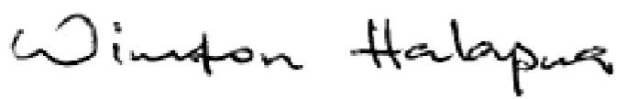



W Halapua P Richardson WB Turei
Primate and Archbishop Primate and Archbishop Primate and Archbishop

